
Name: _______________________

Stage 3 Physics – Sound and Waves Test 2015

Write your answers in the space provided following each question. Total marks = 50.

Question 1 (2 marks)

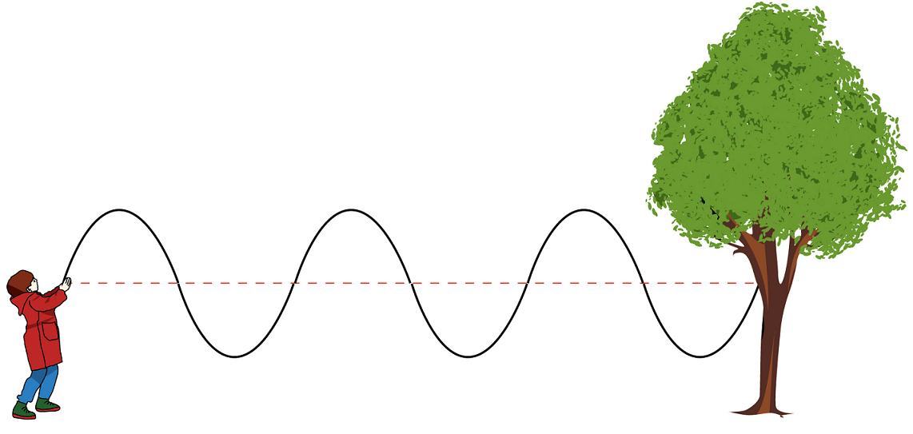
You can make a wave move along a piece of rope by moving one end up and down. At a particular instant, the shape of such a rope is as shown in the diagram. Estimate the amplitude and wavelength of the wave moving along the rope. (no explanation required)

Amplitude: ___________

Wavelength: ___________

Question 2 (2 marks)

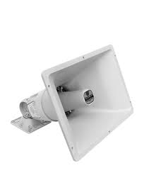
A diffraction horn is a special type of loud speaker that is designed to produce a wide spread of sound into a listening area. Using your knowledge of diffraction suggest how this type of loud speaker is able to produce a wider spread of sound.

Question 3 (9 marks)

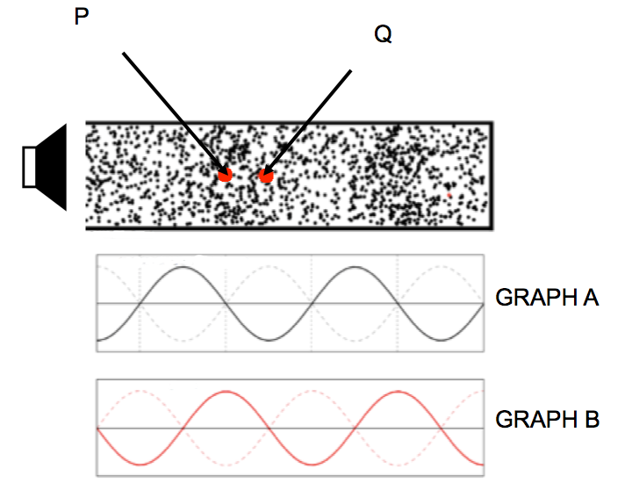
The diagram below shows a closed tube, with a small speaker at the open end. A standing wave is established in the tube. P and Q are two particles of air in the tube.

  - Which graph (A or B) shows the displacement variation along the tube? ________
  - What type of variation does the other graph show? _______________________
  - Which particle is undergoing negligible displacement (P or Q)? ________
  - Which particle (P or Q) is at a “quiet” point in the tube? ________
  - Which harmonic is established in the tube? ______________
  - Given that the tube has a length of 22.5 cm, find the wavelength of the standing wave.
  - Find the fundamental frequency for the tube.

Question 4 (4 marks)

Some Scotch boys start a rock band and are rehearsing in one of their parents’ steel shed. It doesn’t take long for neighbours to complain about the noise.

- Suggest what the boys may be able to do to reduce the noise problem for their neighbours, be sure to explain the Physics behind your suggestions.

- The band discovered that their high noise output problem was partially due to wall panels vibrating dramatically at certain frequencies of their music. Explain how this might occur.

Question 5 (4 marks)

(a) Briefly describe the difference between a musical note and noise.

(b) What Physics terminology best describes Pitch, Loudness and Quality (timbre).

Pitch: _______________ Loudness: ________________

Quality: ______________________________________________

Question 6 (5 marks)

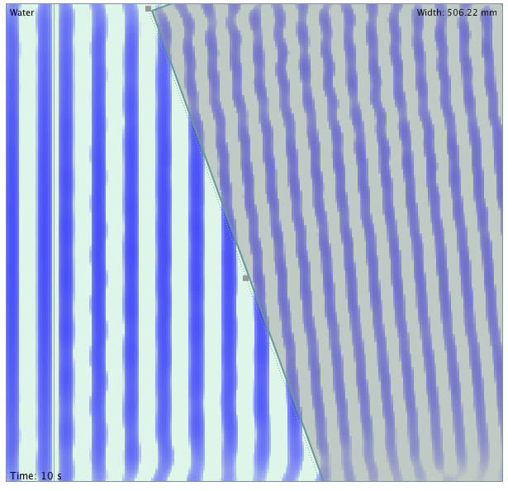
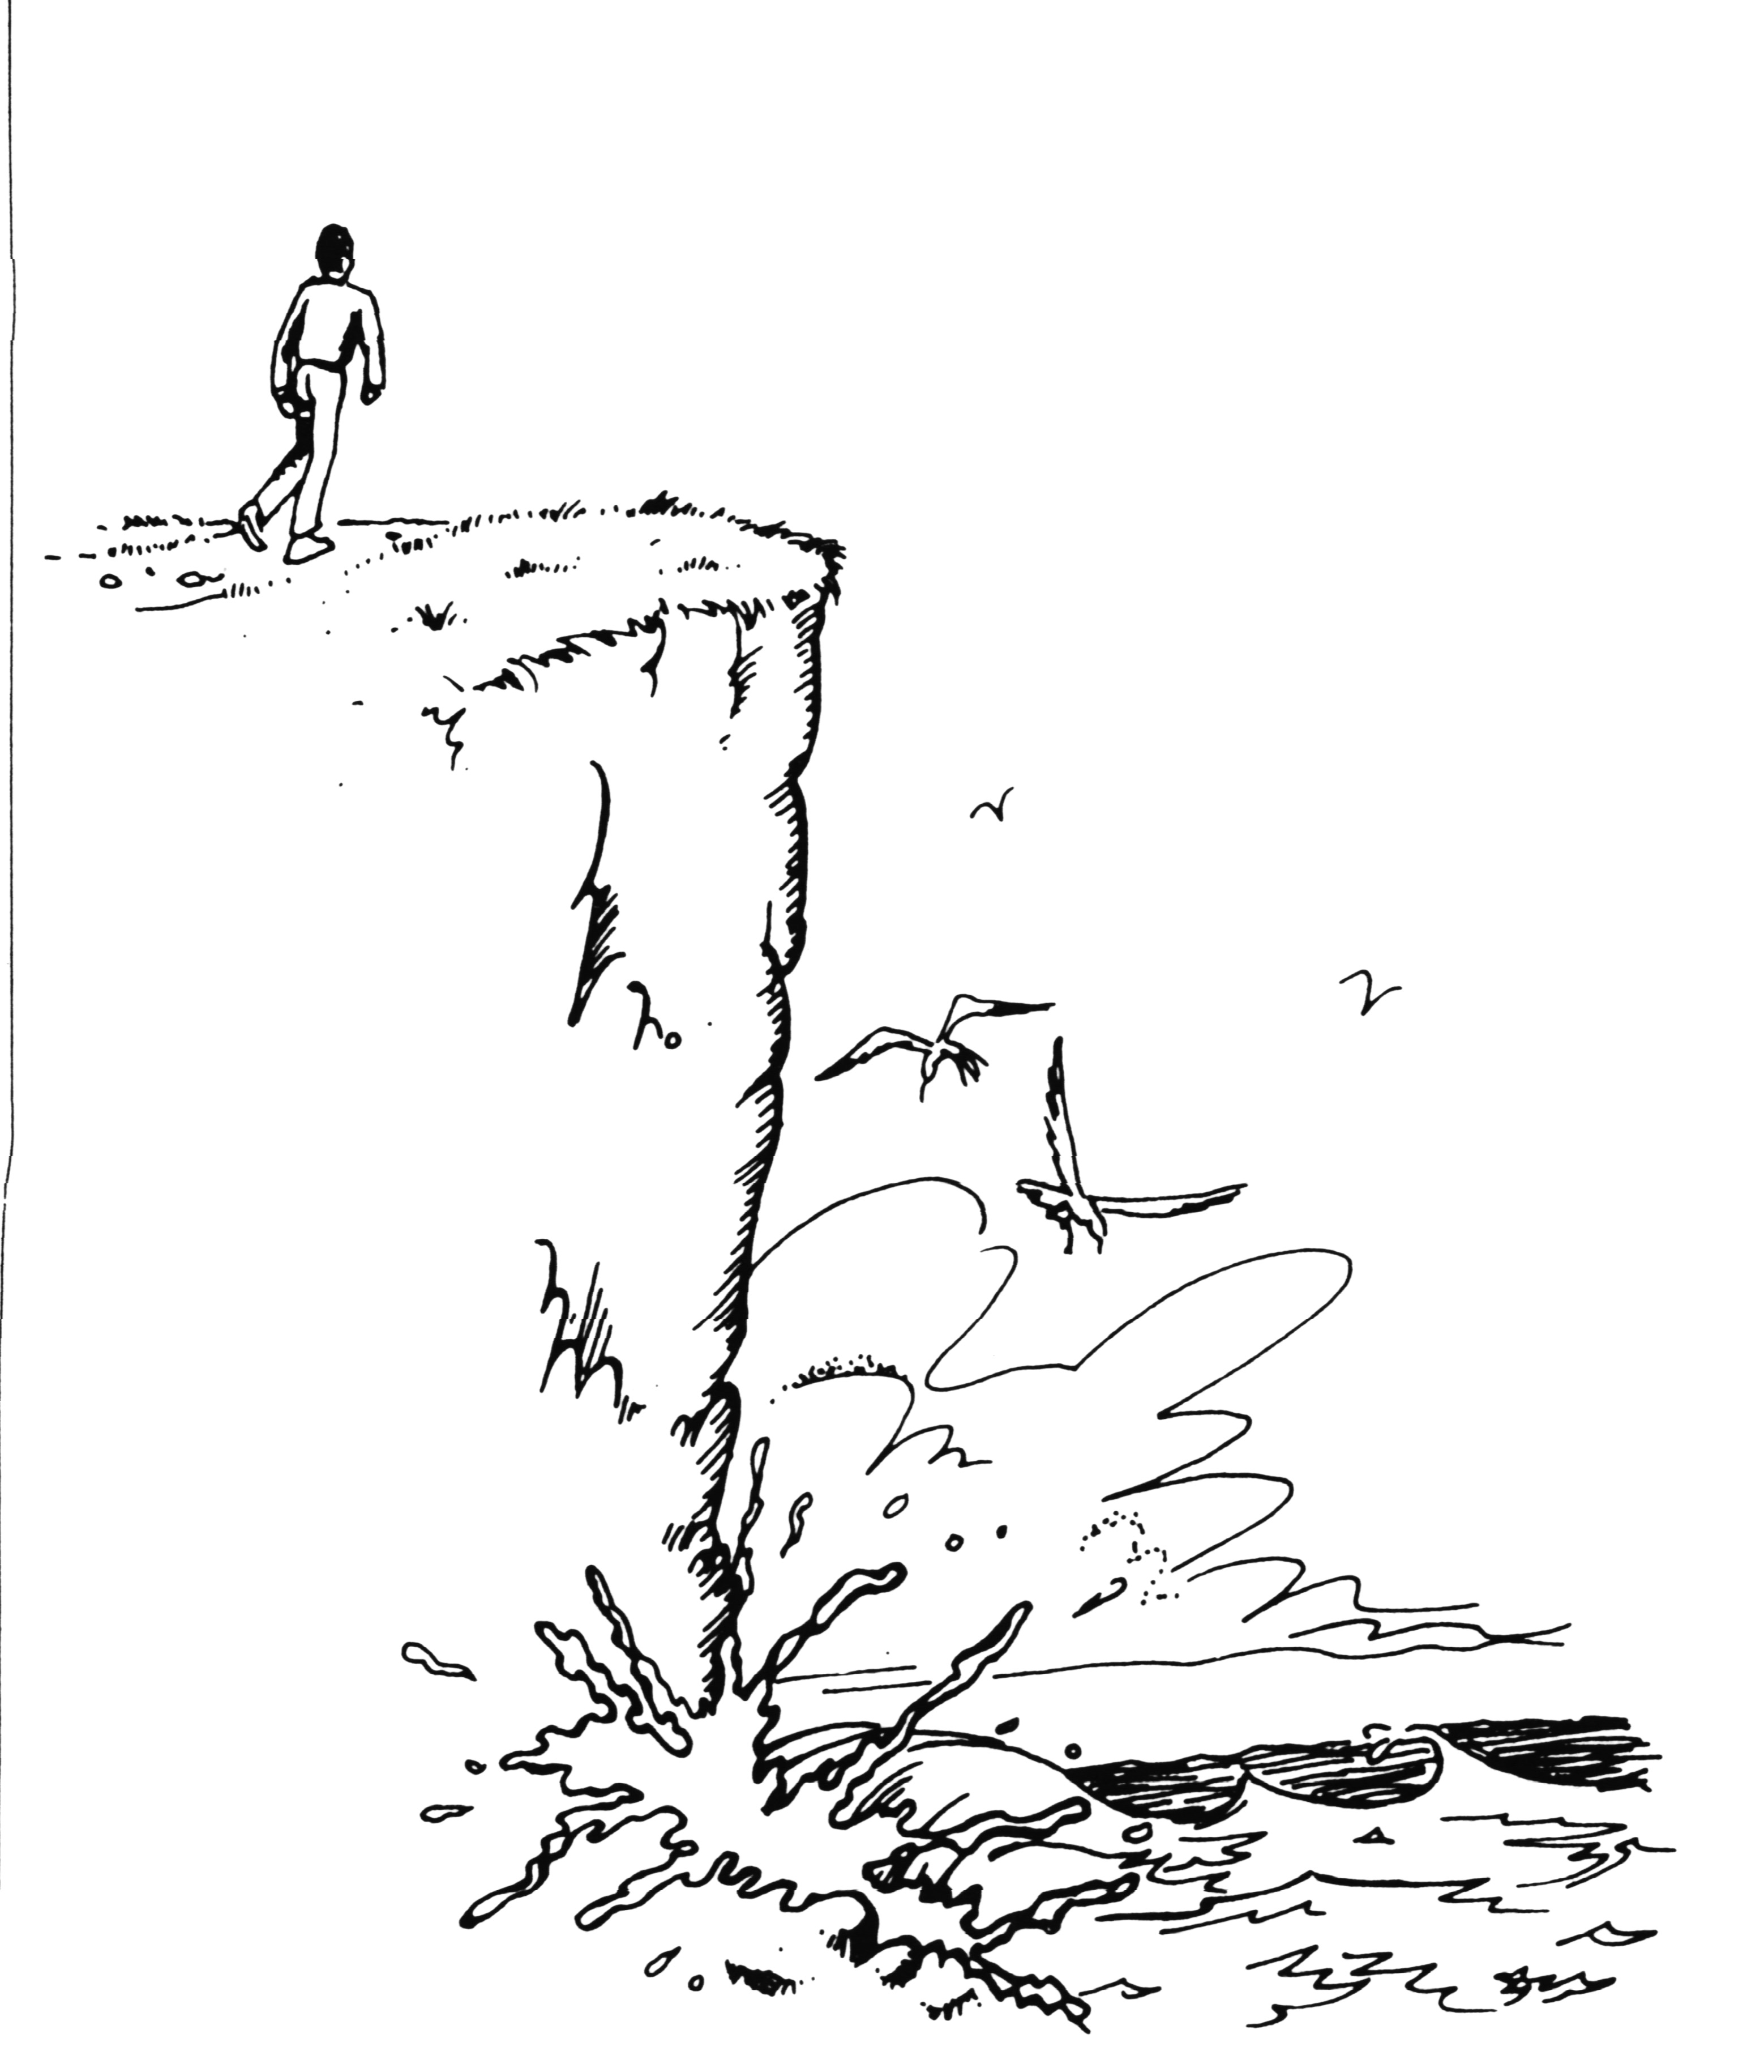
- You are walking along a path on a cliff about a surf beach. The path is not quite on the cliff edge, so you cannot actually see the surf, nor can you see the seagulls that are flying below the cliff.
Explain why you can hear the pounding of the surf, but you cannot hear the cries of the gulls.
- The diagram at the right shows a series of wave crests transitioning from deep water to shallower water.
i). Does the wave speed up or slow down when it enters shallow water?

ii). What wave behaviour is illustrated in the diagram?
DEEP WATER SHALLOW WATER
iii). What property of the wave is unchanged as it enters the shallow water?

Question 7 (From the Study Guide) (4 marks)
Tom and Simon connect two speakers (A and B) to a single frequency generator and then investigate the loudness of the sound produced at different points in the Science laboratory. The speakers are placed 2.00 m apart and Tom stands at position Q which is exactly midway between the speakers and a perpendicular distance of 2.00 m from them, whilst Simon stands directly in front of speaker A and 2.00 m from it (and 1.00 m from Tom

- Draw a diagram that shows this situation.
- If Tom walks towards Simon, in what ways will the sound he hears vary? Explain.
- Simon cannot hear any sound at his position. Determine the minimium frequency of the sound being emitted by the two speakers. (Assume that the speed of sound is 340 ms⁻¹)

Question 8 (5 marks)

The picture below shows the resultant of two waves, WAVE 1 (shown) and WAVE 2 (not shown). Study the picture carefully, and answer the questions that follow.
WAVE 1
RESULTANT

a) Sketch WAVE 2, so that the resultant of WAVE 1 and WAVE 2 is as shown above.

b) Complete the following information about WAVE 1, WAVE 2 and the RESULTANT

 | WAVE 1 | WAVE 2 | RESULTANT
AMPLITUDE
FREQUENCY
PERIOD

c) Label with a “C” all points of maximum constructive interference.
Label with a “D” all pints of maximum destructive interference

Question 9 (15 marks)
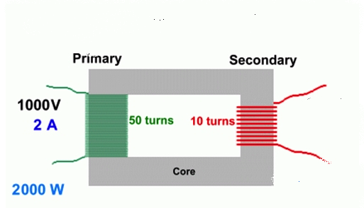
The diagram at right shows a basic transformer, with the supply voltage to the primary coil being 1000 V AC.
(a) By examining the diagram, determine the output voltage from the secondary coil. [2 marks]

(b) Why is it essential that the supply to the primary coil should be an A.C voltage? [1 mark]

(c) Suggest a material for the core. Give a reason for your choice. [2 marks]

(d) State an essential design feature of the core AND explain why it is necessary. [2 marks]

The four large generators at Muja A power station near Collie can deliver a maximum electrical power of 800 MW. This power helps supply the electricity needs of Perth and is stepped-up to a voltage of 330 kV before transmission along cables connecting the power station to the city. These transmission cables have a total resistance of 4.5 Ω. At the city end, the transmission lines are connected to a series of step-down transformers to reduce the voltage to 240 V.
(e) Explain why transformers are used to step-up and then step-down the voltage at different stages of power transmission. [2 marks]

(f) Calculate the current flowing in the cables when the power station is delivering maximum power. [2 marks]

(g) What is the voltage drop along the transmission cables, and what is the voltage supplied at the city end of the transmission cables? [2 marks]

(d) Determine the electrical power lost as heat in the cables, and the percentage power lost in the transmission lines. [3 marks]

END OF TEST

